Electricity and Magnetism

These experiments introduce young children to the concept of electromagnetism. We begin with a simple demonstration about magnets to discuss positive and negative charges, show the electricity and magnetism are two aspects of the same phenomenon, and then build simple electric circuits.

## Magnets

Discuss the two sides of a magnet, which are denoted as positive (+) and negative (-). Ask if students know that “opposites attract,” but like charges will repel. Demonstrate with magnets. It is helpful if you label the ends of a bar magnet with (+) and (-) so that students can “see” the charges on the magnets.

## Static Electricity

**Materials**

Balloons

Plastic bag

Towel

Reference: http://www.stevespanglerscience.com/lab/experiments/static-flyer-flying-bag/

**Directions**:

1. Cut a strip from a plastic bag, making a loop or ring.
2. Blow up a balloon and tie off the end.
3. Rub the towel on the balloon for 30-45 seconds.
4. Flatten the plastic band on a hard surface and rub it on the towel for 30-45 seconds.
5. Hold the plastic band over the balloon and watch it levitate.
6. Alternatively, you can rub the balloon on someone’s hair.

**Alternative:** Swiffer experiment https://trdye.wordpress.com/2013/01/21/electrostatic-forces-and-the-secret-to-swiffers-swiftness/

**Explanation**: Rubbing the towel on the balloon and the plastic band transfers a **negative charge** to the surface of both objects.This is caused by a contact-induced charge separation or triboelectric effect. Because both are negatively charged, the balloon and plastic band repel each other.

## Electromagnetism

A current in a wire induces a magnetic field around the wire. A magnet, placed next to the wire, will attract or repel the wire depending on the direction of the current flow (and the right-hand rule).

The topic can be introduced by asking children if they know what circuits are, and if they know about the two charged particles and current. **Protons** are positively charged particles and **electrons** are negatively charged particles. Electrical currents are caused by electrons flowing in an electric field, but by convention, **current** flows from positive to negative (in an electric field).

**Materials**

Long piece of wire

Battery

Alligator clips

Magnets

Reference: http://www.exploratorium.edu/snacks/motor-effect

**Directions**:

1. Strip the ends of the wire. Try to straighten the wire as much as possible because it makes it easier to visualize any movement in the wire.
2. Tape the ends the wire to the table. Connect alligator clips to both ends.
3. Place the magnet next to the wire. Show that nothing happens.
4. Clip both ends of the battery to the alligator clips. (Note that there is low resistance in the wires, so don’t leave this connected for a long time as the battery can get hot!)
5. Place the magnet next to the wire again. You can also flip the magnet around to see the opposite effect.
6. Switch the battery terminals, which switches the direction of the current. The opposite effect happens.

**Explanation**: Electricity and magnetism both result from the electromagnetic force. In this experiment, we learn that the electric current in the wire induces a magnetic field surrounding the wire. The magnetic field is determined by the “**right-hand rule**.” If you wrap your right hand around the wire with the thumb in the direction of the current, then your fingers are pointing in the direction of the magnetic field. Although we cannot see the magnetic field, we can hold a magnet next to the wire and see that the wire is either attracted to or repelled from the magnet. What happens if you switch the direction of the current, or turn the magnet around? The wire do the opposite (it will be repelled or attracted to the magnet).

## Circuits

We will build simple circuits using a breadboard, wires, and electrical components. A **breadboard** or plugboard is a construction base that makes it easier to build circuits because the electrical terminals on the board are interconnected (see the breadboard diagram at the end). The electrical components that we have are **batteries**, **resistors**, **LED**s (light emitting diodes), and more advanced components such as buttons and motors.

Build a circuit

1. Simple circuit with a battery, resistor, and LED (no wires)
2. More complicated circuits

**Note: Do not build a circuit without a resistor, or else the diode will burn out!**

1. Simple Circuit (Example)

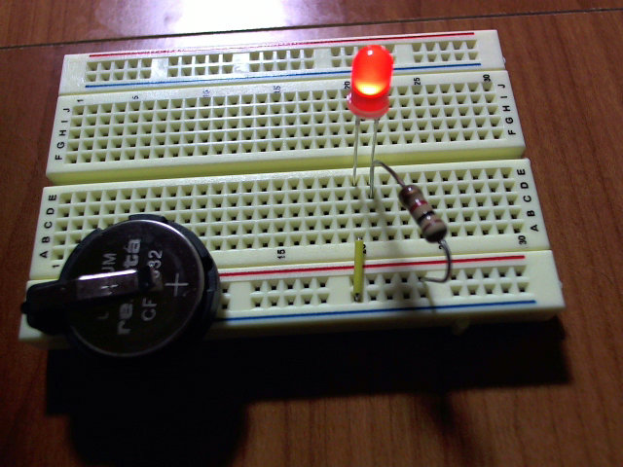

Build a circuit that includes only an LED, a resistor, and as few wires as necessary. Notes:

1. On the battery, the red side = positive and black = negative
2. The longer leg of the diode is the positive side.
3. The **positive** side of the circuit must flow to the **positive** side (longer leg) of the diode.
4. If the LED doesn’t work, check that the direction is correct. If it is, then you could also try a lower resistor. If nothing works, the LED could have burnt out.

**Additional Info**:

Breadboard Diagram - This shows that the rows are connected, as well as the two red/blue columns on either side.

